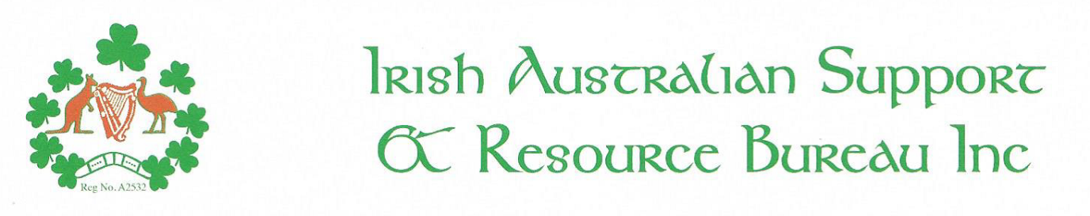MEMBERSHIP - 1 JULY 2020 to 30 JUNE 2021
If you have previously opted for the 6 year deal then please ignore this form or use it to inform us of any changes to your contact details
□Mr □Mrs □Ms □Miss □Dr □ other………………… Surname…………………………………………………………………………………………………………………………………
Given Name(s)……………………………………………………………………………………………………………………….
Home Address …………………………………………………………………………………………………….…………..….. …………………………………………………………………………………… Postcode…………………….….
Postal Address (if different from above)
………………………………………………………………………………………………………………….…... ……………………………………………………………………………………. Postcode…………………………
Home Telephone…………………………………………… Mobile……………………………………………………………...
Email Address ……………………………………………………………………………….……………..
Email would be the preferred method of corresponding with you
Contact preference:
Home phone□ Mobile □ E-mail □ Post □

Signature: …………………………………………………………………… Date: ……………………………………

Please tick which class of membership is requested for renewal;
Ordinary Membership (one year) $10.00 □ Previously paid Membership 6 yr. □
Ordinary Membership Deal (six year) $50.00 □

Membership Fee $................. Donation (optional): $.................. TOTAL $ …………….….. _______________________________________________________________________________

Methods of payment:

Please make cheques payable to;
Irish Australian Support & Resource Bureau Inc.
Post with completed form to: 440a High St, Northcote VIC 3070

OR Accepting card payments in person or over the phone

OR By Bank Transfer;

Account Name: Irish Australian Support & Resource Bureau Inc
BSB: 083-495 Account No. 01-866-7911
Bank: NAB
Quote Reference: Initial & Surname
If paying by bank transfer, please advise us by e-mailing completed form to: iasrb@iinet.net.au

